|  |  |
| --- | --- |
| **Analog signals** | **Digital signals** |
| Analog signals are difficult to get analysed at first. | Digital signals are easy to analyse. |
| Analog signals are more accurate than digital signals. | Digital signals are less accurate. |
| Analog signals take time to be stored. It has infinite memory. | Digital signals can be easily stored. |
| To record an analog signal, the technique used, preserves the original signals. | In recording digital signal, the sample signals are taken and preserved. |
| There is a continuous representation of signals in analog signals. | There is a discontinuous representation of signals in digital signals. |
| Analog signals produce too much noise. | Digital signals do not produce noise. |
| Examples of analog signals are Human voice, Thermometer, Analog phones etc. | Examples of digital signals are Computers, Digital Phones, Digital pens, etc. |

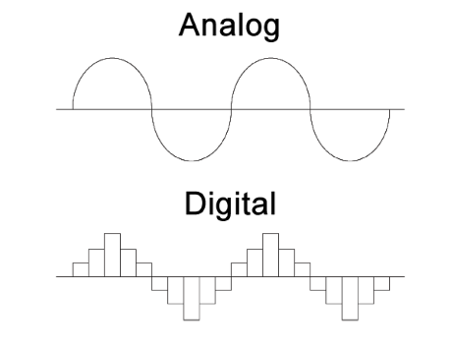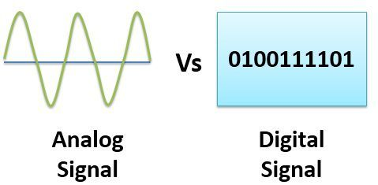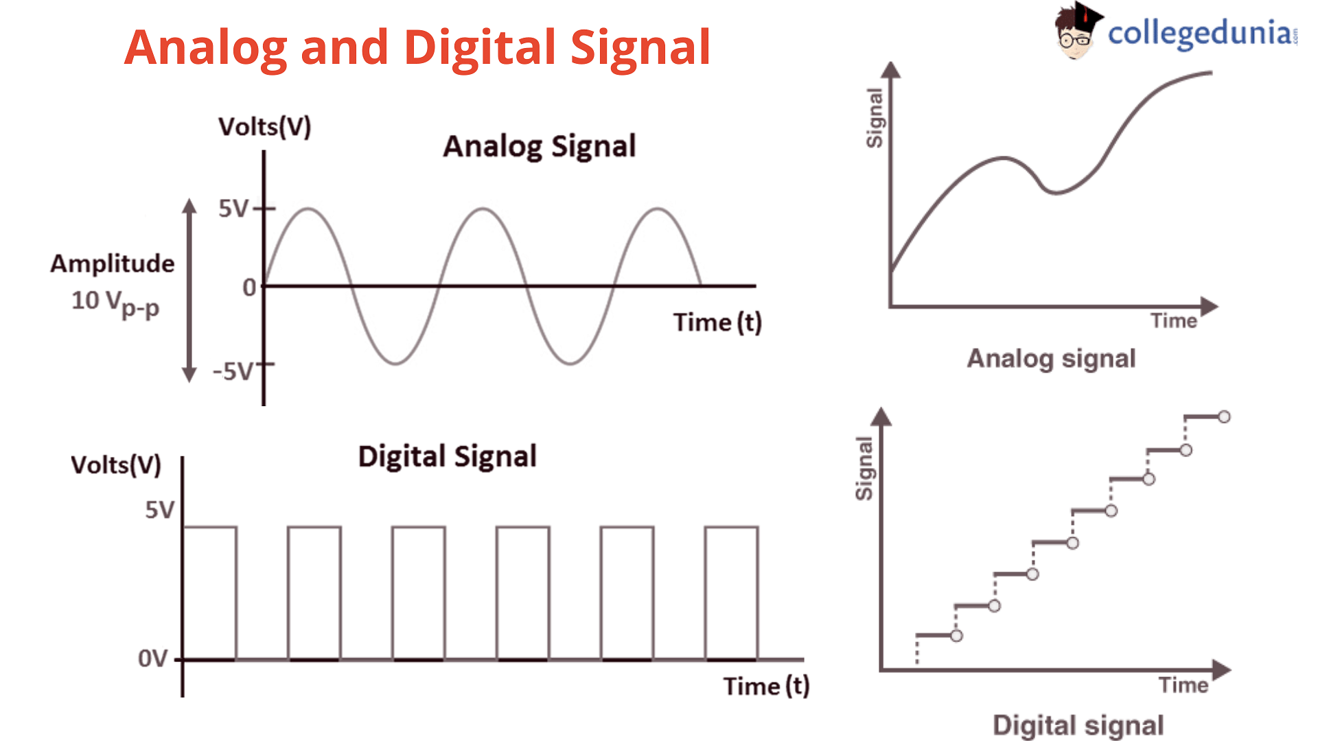

[Difference Between Analog Signals and Digital Signals - Javatpoint](https://www.javatpoint.com/difference-between-analog-signals-and-digital-signals)